MIS3306 Database Management Systems

Project 2

40 points

* *Names and Contributions* (5 points deduction for insufficient information)

Clearly list the names in your group and describe the contribution of each member. The list below is an exemplary list of contributions. Your team members may have other contributions but you have to describe clearly.

* + Draw the revised ER diagram for Project 2.
  + Write SQL codes for creating tables.
  + Write SQL codes for inserting data.
  + Configure the cloud database environment (i.e., in the 000webhost.com).
  + Consolidate SQL codes, execute, and debug.
  + Revise and match the ER diagram with the resulted database.
  + Prepare and submit the project document.
  + Coordinate the project works/members and ensure the schedule (the project manager).
  + Other: Describe clearly…

**Answer:**

|  |  |
| --- | --- |
| Group Member Name | Contribution (pick from the list or describe yourself) |
| Shamila Fernandez | * + DRAW THE REVISED ER DIAGRAM, PREPARE AND SUBMIT PROJECT, Coordinate the project works/members and ensure the schedule (the project manager). |
| Estelle Simmons | * + WRITE SQL CODES FOR CREATING TABLES, Coordinate the project works/members and ensure the schedule (the project manager). |
| Karim Issa | * + WRITE SQL CODES INSERTING DATA, Coordinate the project works/members and ensure the schedule (the project manager). |
| Aaron Alex | Did Nothing |
|  |  |

# This document includes three sections:

1. Learning Objectives
2. [Requirements](#_Requirements_(SUBMIT_FOUR)
3. Your Answers

# Learning Objectives

(back to top)

From the project 2 you and your team will learn the following objectives in team work:

1. (Module 8) Create a database and select data types
2. (Module 8) Use SQL to create a table
3. (Module 8) To add, modify, and remove columns and constraints
4. (Module 8) Use SQL to insert, update, and delete rows of data

# Requirements (SUBMIT FOUR FILES FOR GRADING)

(back to top)

Your group should submit **four** files into Canvas for grading, including (5 point for missing each document):

1. **Database design in the Visio format**: E-R diagram, in the Visio format, indicating tables, relationships, columns, data types, and null status.
2. **One SQL script (table.sql)** for creating ALL tables (Not DBMS generated)
3. **One SQL script (data.sql)** for inserting ALL data (Not DBMS generated)
4. **This** Word document with answers (.doc)

The (this) Word document serves as a summary of your work. For grading, I will first read the summary document and then check the Visio file and SQL codes.

# Your Answers

(back to top)

1. (8 points) *ERD with Data Dictionary*

Paste your revised E-R diagram from Visio and the data dictionary. Knowing the diagram may be hard to read in one picture pasted here, I will check your Visio file separately for grading.

**Answer:**

1. 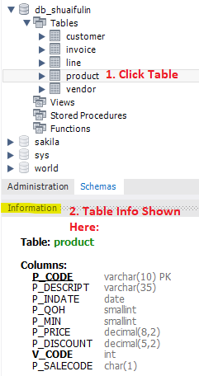(15 points) *Database: Tables*

Show the columns and data types for each table. The SQL codes for creating tables submitted from your group will be graded as well.

**Steps:**

1. In MySQL Workbench, click a table so that the table information is shown.
2. Then, take a screenshot for each table and paste here. Your screenshot should at-least contain Table name, columns, and data types, as shown below.

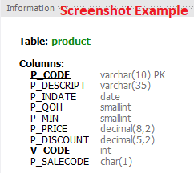

**Answer:**

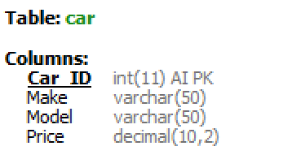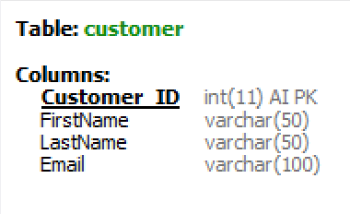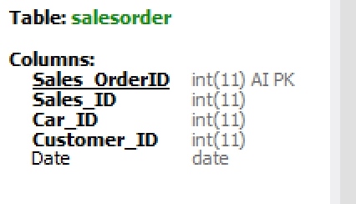

1. (12 points) *Database: Data*

Show the data for each table. The SQL codes for inserting data submitted from your group will be graded as well. At least five records per table.

**Steps:**

1. In MySQL Workbench, right-click a table and choose “Show Rows – Limit 1000”.
2. Then, take a screenshot for each table and paste here. Your screenshot should display for each table all the columns and data.

**Answer:**

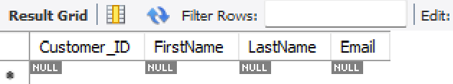 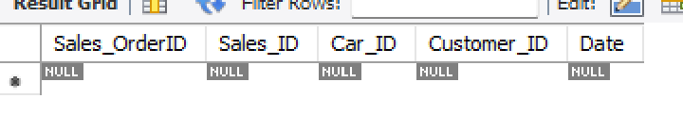

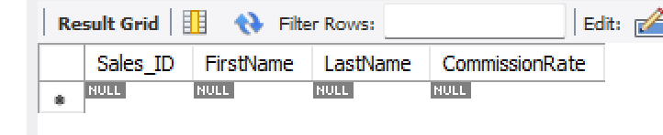

1. (5 points) Idea Creativity and Technical Difficulty

This is for grading purpose only. Do not answer here.